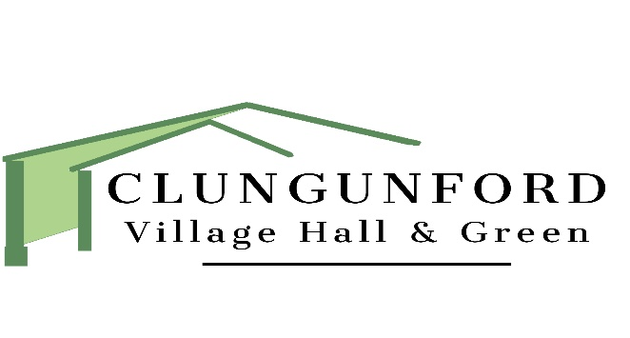

VILLAGE HALL AND GREEN TRUSTEES ANNUAL GENERAL MEETING.
WEDNESDAY 7TH APRIL 2021 VIA ZOOM.

7pm: Formal Meeting
- Chair’s report.
- Financial report
- Question and Answer session
- Election of Trustees.

If you would like to attend please contact Elizabeth Lyster (details below) and she will send you a zoom invitation.

If you are interested in becoming a trustee, or just want to know more about being a trustee, please contact Elizabeth Lyster (Secretary) by 1st April 2021.
Phone: 07843 488663
E mail: lystere@btopenworld.com

