Otter Project
This project uses the information in the educational modules on the website of the UK Wild Otter Trust. Read the modules to help you with the tasks below.
http://www.ukwildottertrust.org/wp-content/uploads/2020/04/UKWOT-Mini-Otter-Modules.pdf
Module 1.
Fill in the gaps:
The ……………………................. otter has been here for millions of years. It is a member of the …………………………………. family, which also includes:
1 | Watch the YouTube video (with your parents permission):  https://www.youtube.com/watch?v=Iu12UBsOE20
2

3

4

5

6

Definition:
Write out what “semi-aquatic” means:
……………………………………………………………………………………………………………………………………………………………………………………………………………………………………………………………………………………………………………………
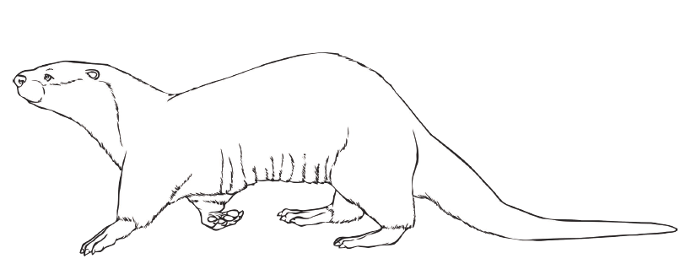
Average length =
Average weight =
True or false?
 |  | True? | False? | Notes if false.
1 | Eurasian otters eat birds, mammals and frogs as well as fish.
2 | Their gestation period (pregnancy) is 9 months.
3 | They only have 1 cub.
4 | They are born with their eyes open.
5 | They come above ground at around 3 months.
6 | They can hold their breath for long periods.
7 | Cubs leave their mothers after 6 months.

Fill in the gaps:
Otters have an acute sense of smell, hearing and eyesight. Its eyes are placed at the ……….. of the head, so it can remain alert whilst the rest of the body is ……………………………………. . They communicate via …………………………………….. , …………………………………………… and ………………………………………………………………….. which can be heard at night when it is quiet and still. Otters live in holes in river banks called ……………………. ; a holt will have a few different entrances to protect against flooding, with at least one entrance being above water level.
Watch the video:
https://vimeo.com/390484714
Chris Packham is a great supporter of the UK Wild Otter Trust …. he saw his first otter, as a boy in the 1970s, on which special day?
Answer: …………………………………………………………………………………
Module 2.
Can you explain why he thinks otters are important? (Clue: they are “Indicator Species” – info about this in Module 2)
Answer: ……………………………………………………………………………………………………………………………………………………………………………………………………………………………………………………………………………………………………………………………………………………………………………………………………………………………………………………………………………………………………………………………………………………………………………………………………………………………………………………………………………………………………………………………………………………………………………………………………………………………………………………………………………………………..
Module 3.
Otters are facing many challenges.
Complete the diagram by writing about these challenges – there are 5 mentioned on the website in Module 3.
Threats to otters

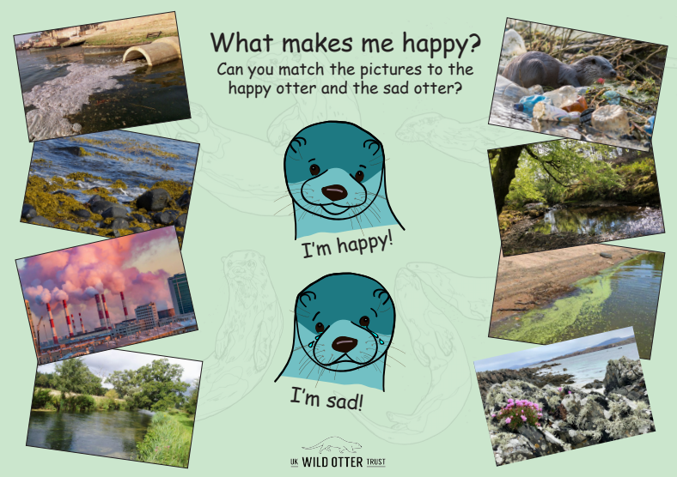
Draw lines connecting the top otter to the environments where it will be happy and in a different colour join the bottom otter to the environments where it would be unhappy.
Module 4.
There are 13 species of otters around the world.
Can you name them (find the information in module 4, there is lots to read here):
1
2
3
4
5
6
7
8
9
10
11
12
13

YouTube task (ask your parents to help you with this):
Find and watch at least four different videos of otters from the topics below, making sure to choose different species. Consider how they are different from one another, and why that might be.
Smooth-coated Otters in Singapore
Asian small-clawed otters in the wild
Asian small-clawed otters juggling stones in captivity
The hairy-nosed otter in Malaysia
North American River Otters having fun sliding on the snow
An animated video about North American River Otters
Why sea otters hold hands
Giant Otters in Brazil
The endangered Southern River Otter
Mazu the Congo clawless otter
Neotropical Otters in Colombia
Learn about the African Clawless Otter
Do you have a favourite otter species? Why is it your favourite?
Answer:
………………………………………………………………………………………………………………………………………………………………………………………………………………………………………………………………………………………………………………………………………………………………………………………………………………………………………………………………………………………………………………………………………………………………………………………………………………………………………………………………………………………………………………………………………………
Module 5.
Otter spotting.
Tick the correct answers:
Draw some otter prints in this box.
Label how they are different to dog prints.
Otters have:
4 toes
5 toes
6 toes

Otter spraint (poo) contains:
Fish scales and bits of bones, shells, insects.
Seaweed and other plant remains.

If you live near the sea or are on holiday near the sea in the UK you may be lucky and spot otter prints in the sand. Otter paths may be found too as they need to wash off the salt in fresh water ponds, lakes and rivers after hunting in the sea. Look out for paths of trampled grass leading from the shore to the nearest fresh water source. If you are very lucky you may actually see an otter too!
In the Western Isles of Scotland there is a young woman called Eilidh who runs a gift shop called the Coralbox on an island called Berneray. Eilidh is a great photographer and has managed to get excellent photographs and videos of otters from her living room as she lives right by the sea where the otters go fishing!
This is her website: https://www.ecwid.com/store/coralbox/.
Ask your parents to look at Eilidh’s social media pages with you (there are links on her website) to watch the otters she has filmed and photographed!
BUT don’t forget…..there are otters in Shropshire too! In fact there are otters right here in Clungunford! Look very carefully and you will see paths, prints and spraint by the river and, if you are very quiet and go looking at dawn or dusk, you may well see them too! If not, I can share a video of them with you that I took using a wildlife, night-vision camera…..just email me and I will send it to you: hrw1@live.co.uk.
If you go looking by the river…do take care….don’t fall in!
And don’t ever harm an otter or its habitat. They are protected by law.
Happy otter spotting!
Colouring to finish off – add a few facts around the otter…..what can you remember from this topic?
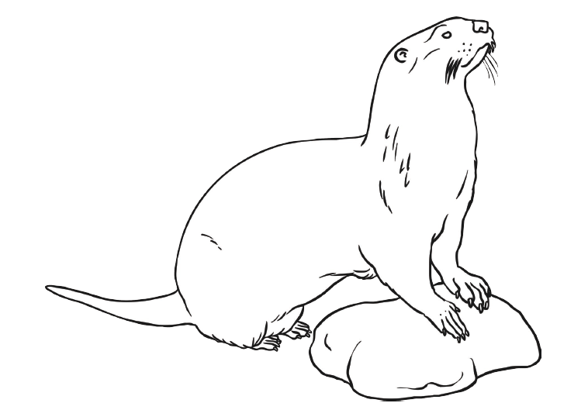
More information:
- Factseet: http://www.mammal.org.uk/sites/default/files/factsheets/otter_complete.pdf
- The best book ever written about living with otters is “Ring of Bright Water” by Gavin Maxwell….read it one day! The film is lovely, do watch it (clips on YouTube – you need a special account to watch the whole movie) but the book is better! It is sad though!

