The Wildlife of the UK
Extras: Read the info sheet below about Grey Seals and highlight more interesting facts about them.
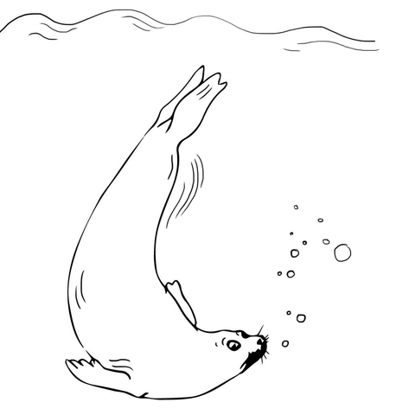
SEALS Activity 1

Facts about Seals (use any books you have or ask to use the internet):
- There are over _____ species of seals.
- Seals eat f_______, b _______ and s_______ f______ .
- The smallest seal in the world is the ___________________ Seal.
- The largest seal in the world is the ____________________ Seal.
- Seals use clicking or t ___________ g noises to communicate.
- Seals can live for over _____ years.
- Seals belong to a group of animals called P_________________ which means: ________________________.
- Seals have a thick layer of fat called _____________ under their skin to keep them warm.
- Animals that eat seals (their predators):
- O________
- S________
- P_________ B________
- UK seals spend time diving, staying underwater for up to ____ minutes and reaching depths of at least ____ metres.

There are two types of seals we can see around the UK:
- Common Seals (also known as Harbour Seals)
- Grey Seals (also known as Atlantic Seals)

The main difference between the two species of seal is that the Grey seal has a much longer s ________ than the Common seal, and the n _________ of the Grey seal are spaced far apart, while they are close together in the Common seal.

Draw the head of a Common Seal and a Grey Seal next to each other to show these differences:
Common Seal (Harbour Seal) | Grey Seal (Atlantic Seal)
Sea

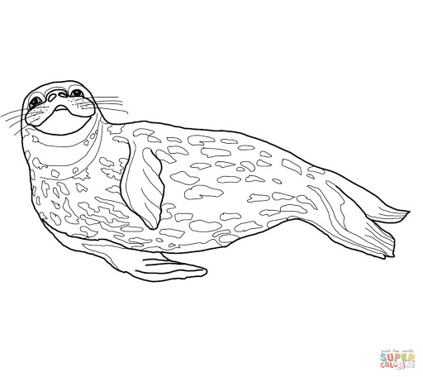
Here’s a seal for you to colour in!
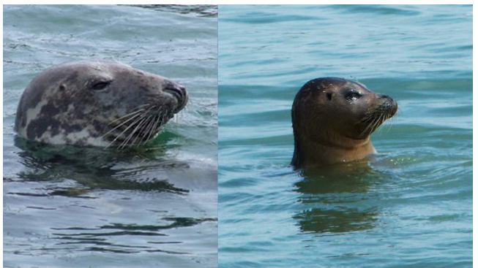
Did your drawings look anything like these?
Left = Grey Seal (Atlantic Seal),
Right = Common Seal (Harbour Seal)

Activity 2.
The three seal predators, draw a picture of each one:

Orca | Shark | Polar Bear

How heavy are seals?
How much do you weigh? _________ kg
An adult Common Seal (Harbour Seal) can weigh up to 130kg.
An adult Grey Seal (Atlantic Seal) can weigh up to 233kg.
Can you work out how much heavier than you an adult Grey Seal might be?
An adult Grey Seal can be _____ times as heavy as ME!
i.e. Grey Seals are BIGGER!
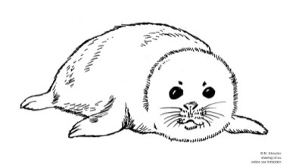
NB A baby seal is called a ________
