Norway Project
The Sami People
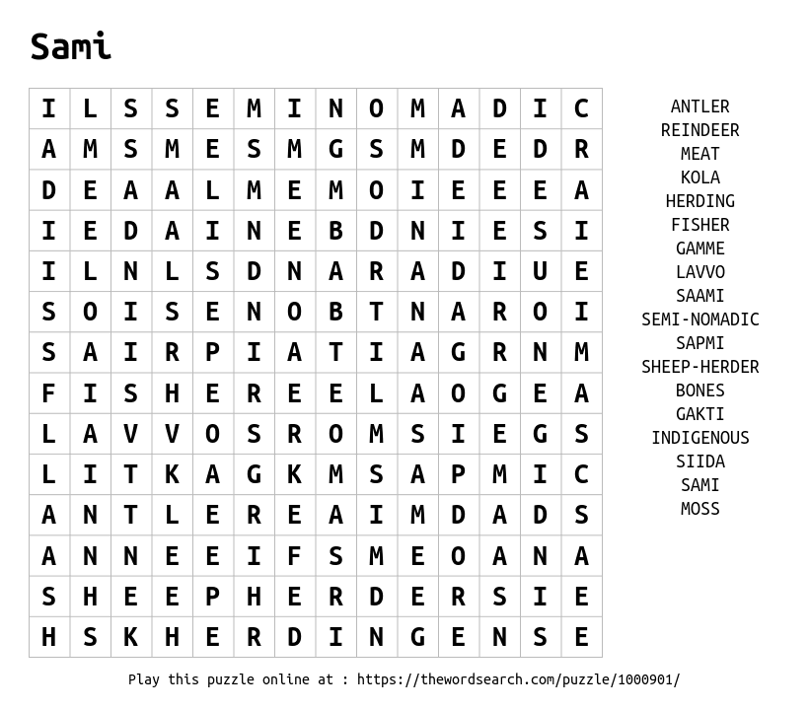
Hi …let’s get started:
Task 1. Complete the word search above.
Task 2. There are some strange new words in there! Right down the words below that you have never heard before:
New vocabulary about the Saami people:
1 | 6 | 11
2 | 7 | 12
3 | 8 | 13
4 | 9 | 14
5 | 10 | 15

We will try and find out what they all mean during the Norway project which will start with studying the Sami people…

The Sami People – a project
Did you know?
In the Disney film, “Frozen” the Northuldra are modeled on the Sami, an indigenous people scattered across northern Scandinavia and north-western Russia.
Kristoff is a Sámi iceman who lives together with his reindeer companion “Sven”. He prefers to live on his own but he helps Princess Anna of Arendelle to find her older sister Elsa in the North Mountain.
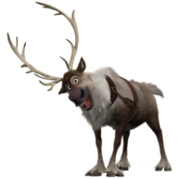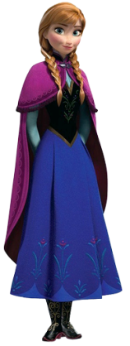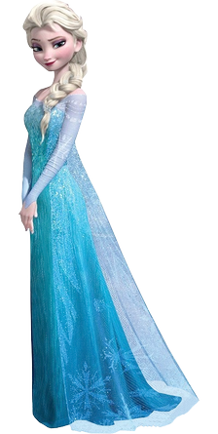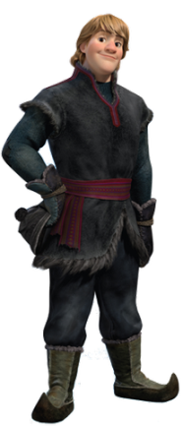
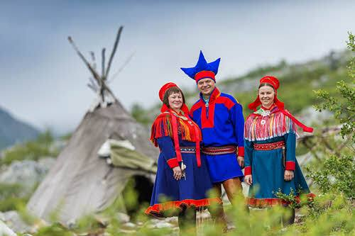
Task. Find out using a dictionary what these words mean:
- Indigenous: ____________________________________________________________________
- Scandinavia: ____________________________________________________________________
Task. Watch the YouTube video abut “Frozen”: https://www.youtube.com/watch?v=oh3-0EoSMFg
Task. The soundtrack to “Frozen” was inspired by traditional Sami singing. Listen to the track: https://www.youtube.com/watch?v=schn6IIJd-U
The Sami people live in four countries: Norway, Sweden, Finland, and Russia (together known as Lapland). The total population in these four countries is estimated at approx. 80,000, of whom around half live in Norway. Slightly under half of these people talk Sami.
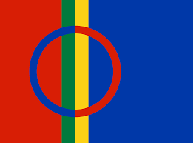
The Sami Flag
Task: Add the circle to the blank flag and then colour it in (in the Sami colours)
Task: Number the countries on the map below and use an Atlas to find out their names. Write the name of each country next to the correct number in the table:

1 |  | 11 |  | 21
2 |  | 12 |  | 22
3 |  | 13 |  | 23
4 |  | 14 |  | 24
5 |  | 15 |  | 25
6 |  | 16 |  | 26
7 |  | 17 |  | 27
8 |  | 18 |  | 28
9 |  | 19 |  | 29
10 |  | 20 |  | 30

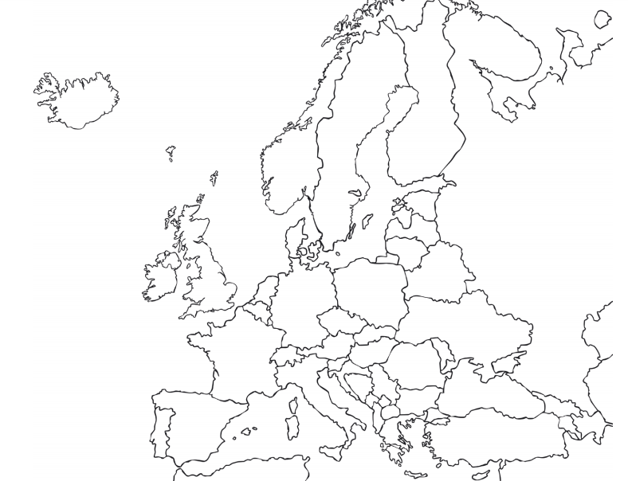

Sami Languages

The Sami languages are very different from Norwegian
A total of nine different but closely related Sami languages are spoken in the Sami region.

The Arctic Circle – many Sami people live north of the “Arctic Circle”. This means:
The Sun is above the horizon for 24 continuous hours at least once per year in the summer (and therefore visible at midnight!) and below the horizon for 24 continuous hours at least once per year in the winter (and therefore not visible at midday!).
In other words they can have 24 hours of daylight in the summer and 24 hours of darkness in the winter!! Imagine that! 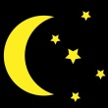
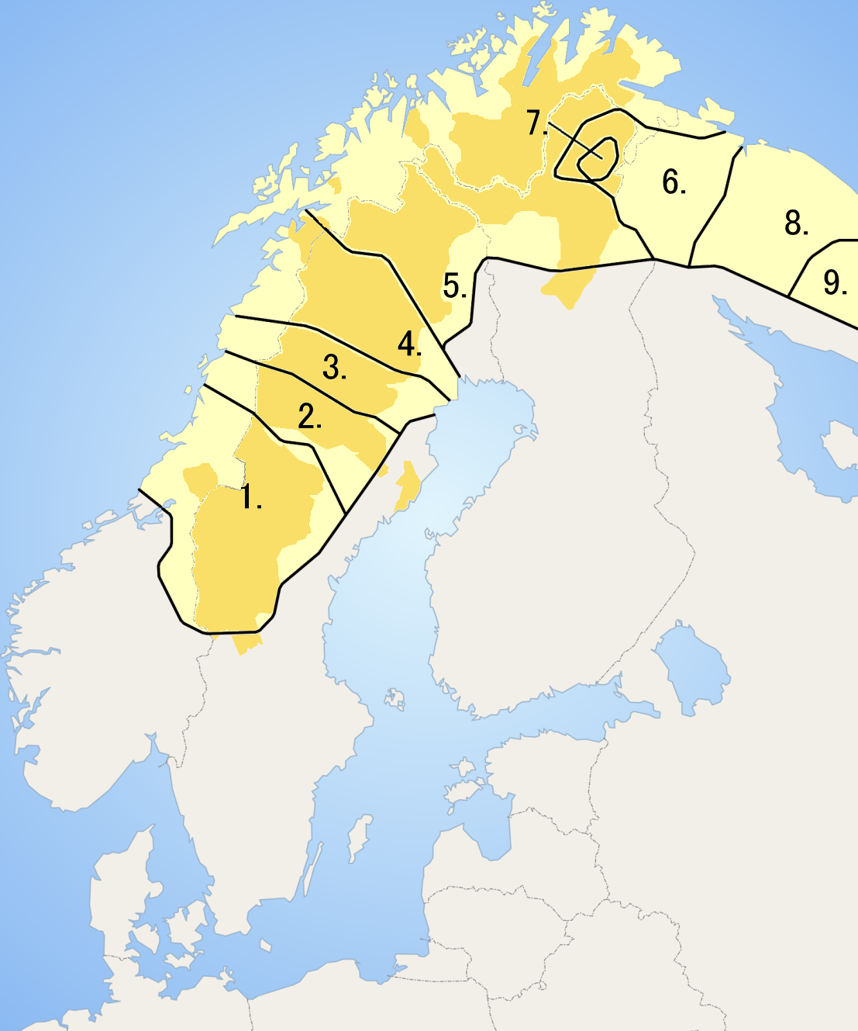
Task: Label Norway, Sweden, Finland and Russia on this map and then colour in the 9 different Sami language regions in different colours.
Notice how the Sami people live in 4 different countries and have 9 different languages!
Task: Can you find the Arctic Circle in your Atlas and then draw a line on this map showing where it is in these 4 countries?
Reindeer
Around 2,600 Sami people in Norway still make their living from herding reindeer.
The Sami used to be able to get everything they needed from the deer. They ate mostly meat, milk, and cheese. Their clothing was made from reindeer skins and wool. Their tents were also made from reindeer skins. The wool clothes were beautifully decorated.

The Sami protected the herds, moving with them as they migrated from summer to winter pastures. They used reindeer to pull sledges carrying their supplies. During the winter, the herds moved south of where the trees grew. The Sami lived nearby in homes made of logs or turf. The Sami were careful not to waste anything they got from the reindeer. Milk was taken from the reindeer to drink or make cheese. Meat was taken for food. The blood was frozen and then used for soup and pancakes. Knives and belt buckles were carved from the bones and antlers. The sinews (tendons) were used as sewing thread. Cleaned-out stomachs were used to carry milk or cheese. Every part of a dead reindeer was used.
Winter clothing was made from layers of reindeer skin. The inside layer would be worn with the fur facing in toward the person's skin. The second layer was worn with the fur facing out. Boots were also made of fur and lined with grass that had been gathered during the short summer. Every evening the grass would be taken out and dried by the fire, so it would be ready to use again the next day. This way, a Sami could be warm and comfortable in even the coldest weather.
Today only a few of the Sami people still follow the herds. Those few use modern tools on their ancient migration. They use snowmobiles to herd the reindeer and rifles to kill the wolves that chase them. Even helicopters and radios are used to locate and move the reindeer. Most of the Sami people now live on small farms in one of the four nations of Lapland. They raise crops and animals, including a few reindeer, to meet their needs. The sale of reindeer meat is an important source of income for the Sami people.

Task. Read the information above and answer the following questions:

- Reindeer can provide m……., m…….. and c………. to eat.
- Reindeer blood can be used to make ……………………………………………………..
- Bones and antlers can be carved into ……………………. and ……………………….
- Sewing thread can be made from reindeer …………………………………………….
- Cleaned out reindeer stomachs can be used to carry …………… or ……………
- Winter clothing is made from …………………………………………………………………
- Fur boots are filled with ……………………… to keep feet warm.
- Nowadays the Sami use ……………………………………… to herd their reindeer.
- The reindeer are located (found) using ………………………….. and ……………..
- Most Sami now are settled and live on small ……………………

Task. Reindeer fur is thick and each hair is hollow…watch this YouTube video to find out why. https://www.bbc.co.uk/programmes/p05rprbw
Write your answer here: ………………………………………………………………………………………………………………………………………………
………………………………………………………………………………………………………………………………………………

The Sami Reindeer herders have an annual migration ending around Easter.
Task. Watch the video:
https://nordnorge.com/en/artikkel/the-kautokeino-easter-festival-is-not-to-be-missed/

The Kautokeino Easter Festival
Reindeer Racing, concerts and gigantic weddings. The Easter Festival in Kautokeino is the high point of the year for the Sami.
At Easter, the sun has returned and the daytime temperatures are really pleasant. Just before the start of the reindeer spring migration, it is the perfect time to hold parties, weddings, christenings and to meet up and have a chat with friends. This is the origin of the Easter Festival. Sami weddings often involve a thousand guests, and thick reindeer soup is served at several sittings. The people of Kautokeino have now become used to setting aside the entire Easter week for a wonderful mixture of parties, fun, church services, cultural events and exciting competitions.
The Easter Festival is held just before the reindeer spring migration. Find out what the word migration means and write your answer here: ………………………………………………………………………………………………………………………………………………………………………………………………………………………………………………………………………………………………

Reindeer racing is a big sport in the Sami community
The World Championships in Reindeer Racing is held in Kautokeino. Races are run in two classes: on skis behind the reindeer and lying flat on one’s stomach on a sledge around a prepared course on the ice. The atmosphere is exciting when the best reindeer from all over Sápmi, the Sámi homeland, line up, and the competition nerves can easily result in the reindeer bolting. Even if your reindeer was not the fastest, you could still win the prize for the best costume.
Task. Draw a picture here of a Sami racer on skis behind a reindeer OR lying on their tummy on a sledge being pulled by a reindeer!

The World Championships in Lassoing generate as much excitement as the reindeer racing. The competition involves lassoing reindeer antlers placed at different distances from the competitors, and the trick is to keep your nerves in check in front of a large crowd.

The Sami Grand Prix is unique
The “Sami Eurovision” is a music competition with participants from all over Sápmi. Singers compete in two categories: joik and pop music. Joik is traditional Sami singing. Just like at the Eurovision Song Contest, the audience decides the winner, so Sami radio transmits the competition directly and processes the votes cast from all parts of Sápmi.

Concerts are a big part of the festival
The concert programme throughout Easter weak is very varied and comprises Sami rock, jazz and joik-inspired music, as well as appearances by nationally famous Norwegian performers. Mari Boine, the most famous Sami singer, often makes an appearance and Beaivváš, the Sami theatre, usually presents a special event as well.
Task. Listen to Mari Boine here: 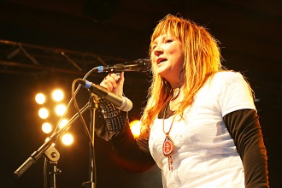
https://www.youtube.com/watch?v=Xaav56mKklY&list=RDNyB90aNkURU&index=6
Her drum is a traditional Sami drum made from reindeer skin and decorated.
Task. Draw the drum here:

Task. Have a go at making your own drum and make a recording of you playing it to send to friends and relatives. Use this YouTube video to help you:
https://www.youtube.com/watch?v=-COHNyFTOnc
Lifestyle
Traditionally, most Sami people supported themselves through reindeer herding, fishing, animal farming, and hunting. They were nomadic herders.
Task. Can you find out what this means?
A nomadic herder is someone who: ………………………………………………………………………………………………………………………………………………………………………………………………………………………………………………………………………………………………
Today, a large number of the Sami people live outside the traditional Sami areas and have moved into the towns. In Northern Norway this would be to towns like Tromso or to the Oslo area. Oslo is the capital of Norway. Many do still live in Sami settlement areas in tents but earn their living in more modern ways: shops, offices, industry. No Sami people live a completely traditional life today.

The Goahti is a reindeer herder’s home 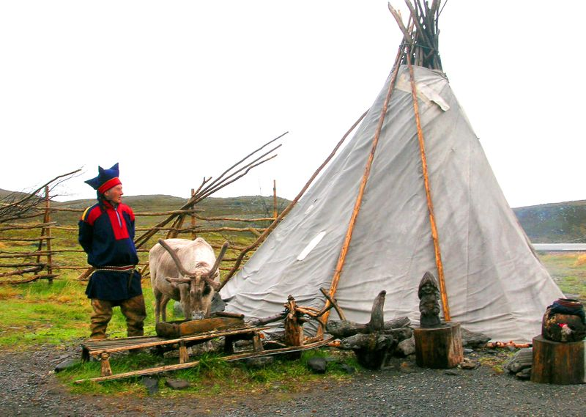
A goahti = a Sami tent. It is supported by two pairs of curved poles. This basic structure forms the support for thinner poles that are laid around the walls. The outside covering is a broad sheet of wool, loavdda, or a thinner material such as canvas.
A smaller, simpler tent is the lavvo.
There is more room in a goahti, and it’s more comfortable than a lavvo. If people were going to live somewhere for long periods before moving on, they built a turf hut — a non-moveable version of the goahti. This has walls of turf and birch bark, and is more solid.
There isn’t much room in a tent, so there is a place for everything, and everything has its place. The floor area in a goahti is divided into five sections.
- entrance door
- fireplace
- kitchen
- loaidu 1 – living space
- loaidu 2 – sleeping space
Each loaidu is covered with birch twigs with reindeer skins laid over them. Various items of equipment are also kept in the loaidu, such as the dried grass that is used instead of socks inside the fur boots.
A goddess called Sáráhkká lived underneath the fireplace, and it is a custom to leave her a cup of coffee! An inner tent could be hung to protect people from the cold or insects while they slept.
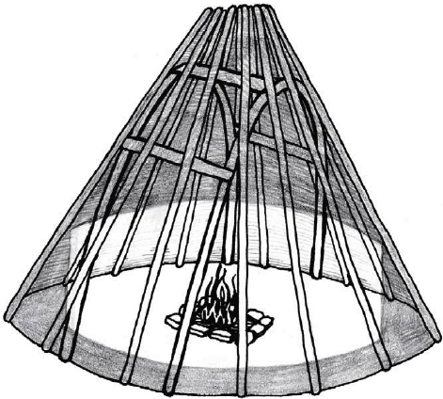
Task. Imagine the oval shape below is the inside floor of a Goahti (Sami tent). Divide up the space into the 5 areas listed above, colour and label the different areas.

Floor plan of a Goahti:

Clothing and Crafts
Duoddji is the Sami word for “craft”, and they enjoy many crafts such as tin embroidery, pearl embroidery, weaving shoelaces, applique, wood carving, and knife-making . Horn spoons, small band looms made from bone, knife handles, pin cushions and bowls made out of birch were decorated with beautiful patterns. Embroidery with wire was very widespread in the southern Sami area, while the eastern Sami people in Finland and the Kola peninsula in Russia tended towards colourful pearl embroidery.
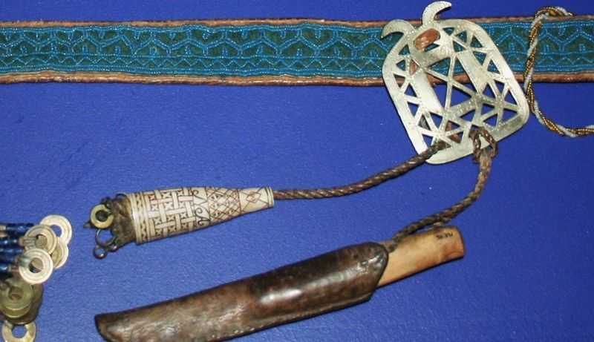

Gákti (or Kofte in Norwegian) is the traditional dress of the Sami and is mostly used when dressing up for celebrations or parties. The costumes vary from area to area in the Sami homelands, but certain elements of the costumes also show which family someone belongs to, who they are related to, or whether they are married or not.
Sami boots filled with a grass called “blister sedge” keep their feet and legs warmer than the latest survival equipment you can buy in mountaineering shops and are used when the temperature drops below -40C.
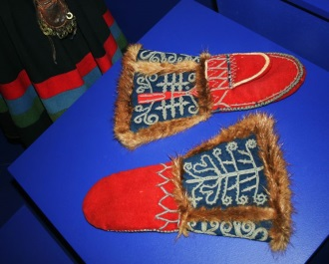 Sami mittens 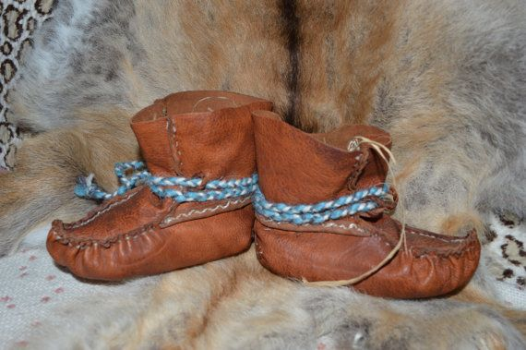 Reindeer skin slippers
Task. Use a highlighter pen to colour in interesting bits of information about Duoddji and Gakti above.
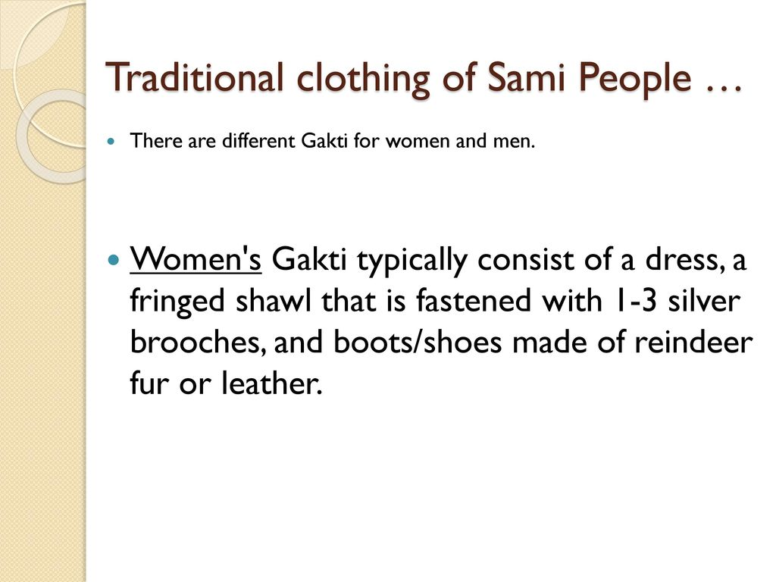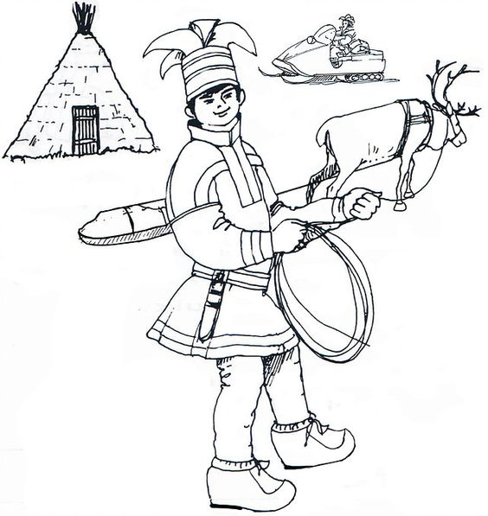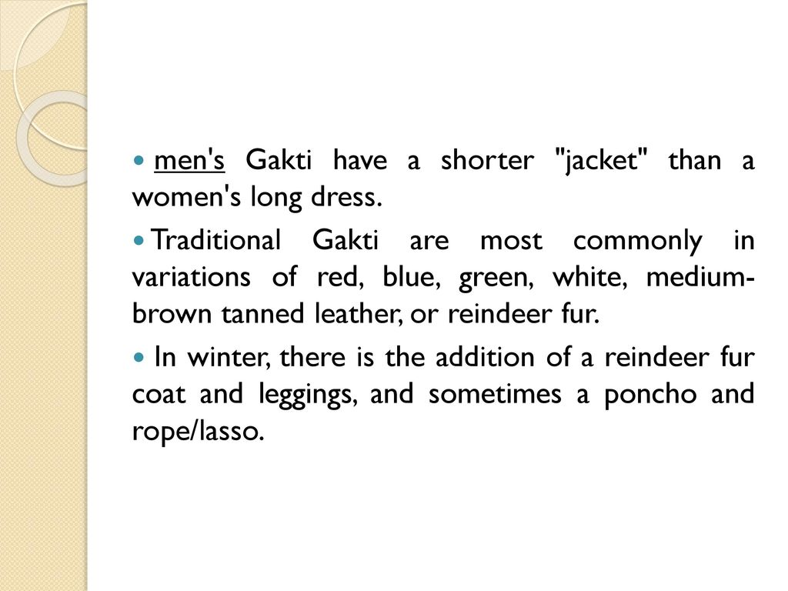
Task: Colour in the Sami pictures here
Task. As you know the Sami wear multi-coloured, often red, pom-poms on their boots and shoes.
If you need a reminder about how to make pom-poms to decorate your own shoes, here you go:
https://www.youtube.com/watch?v=SXFCO3LBJss
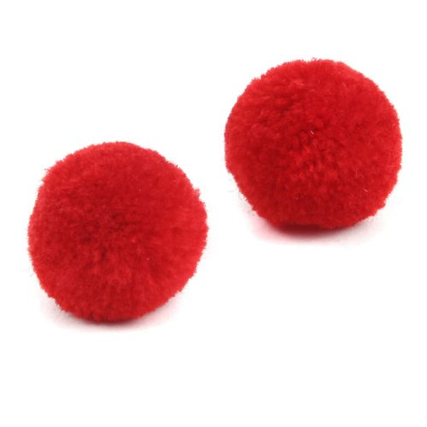

Religion and spirituality

Sami shamanism is the main religion of the Sami people. These beliefs are connected to the land. They believe in spirit animals. Some Sami worship bears. Sami shamanism is a polytheistic religion. It believes there are many gods. The Sami shaman (religious leaders) are called the 'Noadi'. There are 'wise men' and 'wise women' who try to heal people who are sick. They use rituals and herbal medicine. Some Sami people have changed their beliefs to Christianity (in the 1800s they were forced to!).

Task. Shamanism is a polytheistic religion, this means they believe there are ………… gods.

Task. Watch this video a couple of times: https://teachik.com/introducing-the-sami/

How did reindeer create the earth according to Sami mythology?

…………………………………………………………………………………………………………………………………………………………………………………………………………………………………………………………………………………………………………………………………………………………………………………………………………………………………………………………………………………………………………………………………………………………………………………………………………………………………………………………………………………………………………………………………………………………………………………………………………………………………………………………………………………………………………………………………………………………………………………………………………………………………………………………………………………………………………………………………………………………………………………………………………………………………………………………………………………………………………………….

Problems faced by the Sami people.
The Sami people have not always been treated with respect. The Vikings were the first people to take away land from the Sami people. Most problems started for them in the 1800 s. They have also lost land to industry such as mining and dams to create reservoirs for water and electricity power supplies needed in the towns and cities. They have also been badly treated for their religious beliefs in the past and forced to become Christians. If they didn’t they were sent to prison or killed. Their languages were banned.
The government in Norway restricted the number of reindeer each Sami could keep. This affected their food and clothing supplies and income from selling reindeer goods.
Recently there are concerns that climate change is badly affecting the grazing lands of the reindeer. As the climate gets warmer the snow starts to melt during the day but at night it will freeze into solid ice. Over time this means there is just ice and not powdery snow. Reindeer need powdery snow (not ice) as they snuffle through it to reach the moss and grass under the snow.
Task. Watch the video: https://www.bbc.co.uk/newsround/51515024
The Sami today.
Today their culture and lifestyle is more understood, appreciated and protected and they are supported to continue their language and culture and traditions. Phew! The Sami now have their own university and schools and governing body but there is still more work to be done to keep their languages alive. Many Sami have changed to a more modern lifestyle and live in towns and cities but some still like to keep their traditions, live in the country and keep reindeer!
The movie “Frozen 2” does a really good job of helping us understand the Sami. It is important for us to learn about, understand and respect other cultures which may be very different to our own.

Task. So…one last film for you to watch about “Frozen 2” https://www.youtube.com/watch?v=T5F6PDkKlVc
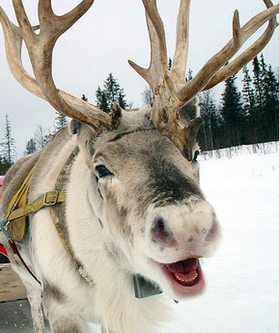 April 2020

