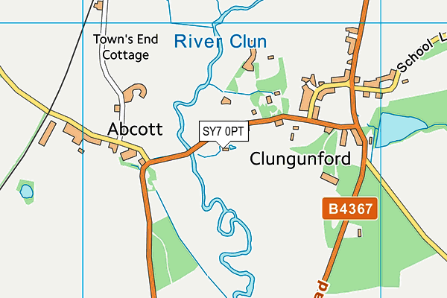
Features to include on my map:

Your local area map
Tasks:
- Make a list (in the box above) of all the places you can walk to easily from home e.g. the village hall, the bridge over the river, the bus stop, church etc….
- Stand outside your front door with a compass if you have one and work out which way is North!
- On a piece of A4 paper draw a large rectangle – this is the frame for your map. Leave space at the top for the title and at the side for a “Key”
- Chose symbols for each feature you are going to include on your map. These will go in your Key.
- Use the map above to help you draw YOUR OWN map of your local area. Use plenty of colour. Start with a symbol for your house!
- At the end remember to check that your map has the 5 things EVERY map should have:
- Key
- Compass (showing which way North is)
- Title
- Frame
- Scale (as your map won’t be drawn to scale, as that’s advanced mapping, just write underneath your map: “Not drawn to scale”)
There is an OS map KEY available for you to look at too….should help with symbols and colours but you can make up your own too! The link to this is in the category: Educational Resources List

